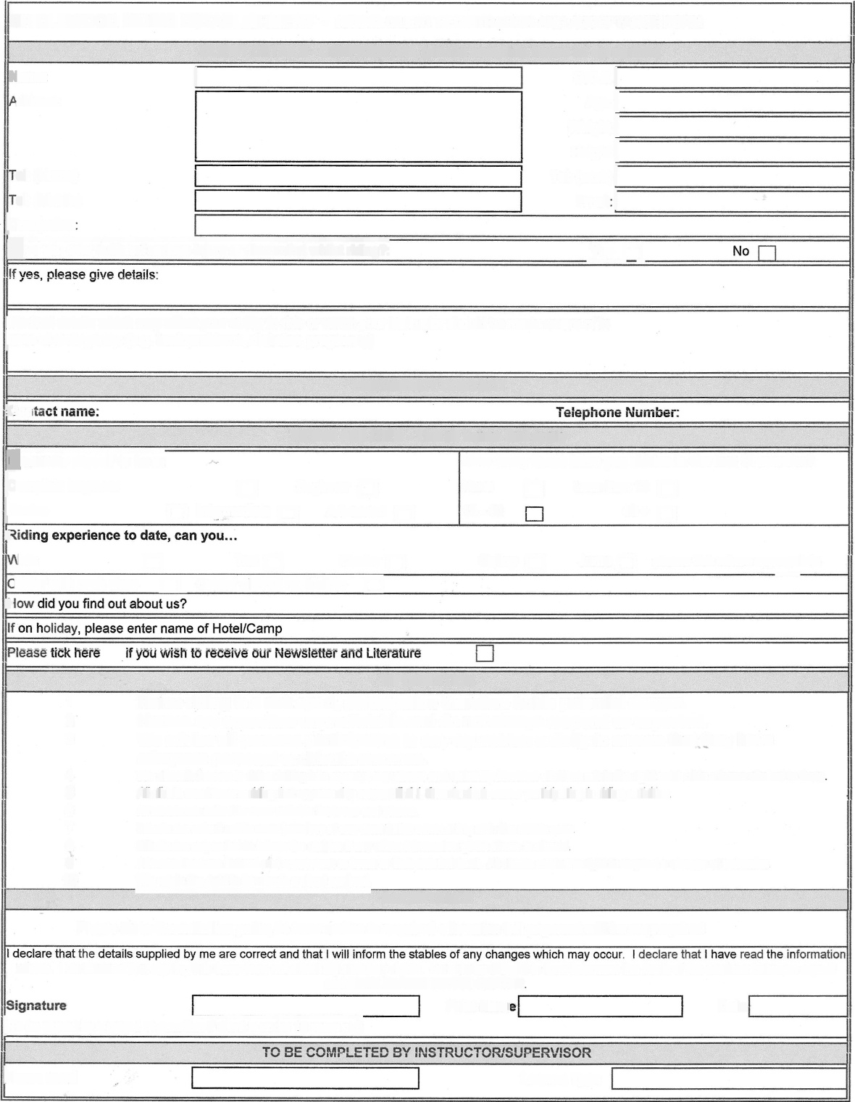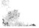
None
a
H
12 - 40
a
He I
BRIDLEWOOD RIDING ESTABLISHMENT - RIDING CLIENT REGISTRATION AND ACCEPTANCE FORM
CLIENT DETAILS - CONFIDENTIAL (please complete boxes as apropriate)
Name:
,ddress:
d: (Home)
el: (Mobile)
IOccupaHon
I D.O.B. I
Age: [
Weight r
Height: [
Tel: (work) i
I
Email
[@ve you ever suffered serious injury or discomfort whilst riding?:
I your lnstructor should be made aware of in
jease of emergency: (e.g. back problems, diabetes, pregnan(v)
EMERGENCY CONTACT
=={} it
RIDING ABILITiES - Tick all boxes that apply
Bon$ider myself to be a:
kQmplete beginner n Beginner [] INca@ n Intermediate [_] Advanced [.]
e
talk H Trot [] Canter [] ;anter with neck strap [i Canterwithout neck strap []
o
How many times have you ridden in the last 12 months?
Less than 12
40 +
Gallop [] Jump [] please tick where appropriate
INFORMATiON
1 Horse riding is a risksport, participation therefore holds potential danger.
2 Horses are sometime unpredictable and do not always respond as expected.
3 We advise all persons participating in any equestrian activity to ensure that they have adequate personal accident insurance.
4 We allocate horses to riders taking into account experience and suitability however aN riders retain the right not to ride a horse allotted to them
5 All clients must wear a riding hat approved to current B.S.I. Standard whenever participating in riding activities.
6 All clients are asked to wear suitable footwear and gloves.
7 Clients are asked not to wear jewellery of any description when riding or in the stable area.
8 Clients are requested to inform the stables if any of the information given above is altered,
9 All instructors are trained and competent to teach to their detailed level. All clients retain the right to request a change of instructor.
10 We retain the right to terminate a client contract.
ACCEPTANCE
Please Note Cancellation polic) 24 hour notice is required otherwise full payment will be nq required
above. I understand that signing this form does not affect my statutory rights. I understand that this form becomes the basis of the contract between myself
and BRIDLEWOOD RIDING CENTRE
Print Nam.
Date
1(To be signed by a parent or guardian if client is under 18 years oN)
[Horse used
Lesson Type
EXCEL\BR:DLEWOOD\FORMS\bwnewdientweald
C :I^{I}, n +

